

Project Interim Report

On

Movie Tickets Booking System (Using Core Java & OOP Concepts)
RU-100-05-00018
Object Oriented Programming with Java

SESSION: 2025-26

Submitted By
Aastha Bhatt

RU-25-10019

Bachelor of Computer Application with
AI and ML in association with Google

Under the Guidance of
Harsh Multani Sir

SCHOOL OF INFORMATION & TECHNOLOGY
RUNGTA INTERNATIONAL SKILLS UNIVERSITY
BHILAI, CG

(April 2026)

Table of Contents

Serial No. | Title | Page No.
1. | Abstract | 3
2. | Introduction  2.1 Key Features….. | 4
3. | Objectives | 5
4. | Scope  4.1 current scope…  4.2 future scope… | 6
5. | System Requirements | 6
6. | Methodology | 7
7. | Flowchart | 8
8. | Class Diagram  8.1 Class Descriptions..  8.2 class:movie  8.3 class: seat  8.4 class:booking | 9,10
9. | Implementation  9.1 movie class  9.2 seat class  9.3 booking class  9.4 main class | 11
10. | Sample Input/Output  10.1 seat layout display  10.2 booking class  10.3 booking confirmation | 12
11. | Gantt chart | 13
12. | Future Enhancements | 14
13. | Conclusion | 15
14. | References | 16

1. Abstract

The Movie Ticket Booking System is a console-based Java application designed to simulate a real-world cinema seat-reservation workflow. The project addresses the challenge of managing seat availability in a multi-row theater while preventing double-booking and computing fare automatically. It models the problem using three collaborating classes — Movie, Seat, and Booking — each encapsulating its own data and behaviour in strict adherence to Object-Oriented Programming principles such as encapsulation, abstraction, and single responsibility. A 2D array represents the seating grid, supporting both Regular and Premium seat categories with distinct pricing. Users can view available movies, inspect the seat map, select seats interactively, and receive a booking confirmation with the total cost. The system is implemented in Core Java without any external frameworks, making it lightweight and educational. Future extensions may include a graphical user interface, database persistence, and multi-show scheduling.

2. Introduction

Online and digital ticket-booking systems have transformed the entertainment industry by replacing manual queue-based processes with instantaneous, error-free reservations. This project replicates that experience at a smaller, educational scale using Core Java and Object-Oriented Programming.
The system allows a user to: browse a list of available movies; view a colour-coded 2D seat map; select one or more seats by row and column index; and receive a printed confirmation with itemised pricing. Booking validation ensures that a seat already reserved cannot be double-booked.

Key Features
• Interactive seat selection via row/column input
• 2D array-based seat grid (Regular & Premium tiers)
• Real-time availability display (O = Available, X = Booked)
• Automatic total cost calculation
• Double-booking prevention with clear error messages
• Booking confirmation with movie name, seat list, and total fare

3. Objectives

1 Objective Simulate Real-World Booking Description Replicate the core workflow of a cinema seat-reservation system.
2 Apply OOP Concepts -Demonstrate encapsulation, abstraction, and object interaction using Java classes.
3 Manage Seats with 2D Arrays -Use a Seat[][] matrix to model the theater layout efficiently.
4 Validate Bookings -Strictly prevent double-booking by checking isBooked before confirming.
5 Calculate Total Cost - Accumulate seat prices and display the final bill at checkout.
Strictly prevent double-booking by checking isBooked before confirming.
6 Deliver Clean Output-Present a formatted seat map and booking confirmation to the user.

4. Scope

Current Scope

• Single-screen, single-show booking session
• Console-based user interface (no GUI)
• In-memory data only (no database)
• Support for Regular and Premium seat categories
• Basic input via Scanner class

Future Scope

• Multiple movies and show timings
• Persistent storage with MySQL or SQLite
• Web-based or JavaFX GUI
• Online payment simulation
• Seat cancellation and refund workflow

5. System Requirements

Component Minimum Requirement

Process Intel Core i3 or equivalent
RAM 4 GB
Storage 200 MB free disk space
OS Windows 10 / Linux / macOS
Java JDK JDK 11 or higher
IDE VS Code / Eclipse / Edit Plus

6. Methodology

The system follows a sequential, menu-driven flow. On launch, movie data and a seating grid are initialised in memory. The user is presented with a list of movies and selects one. Next, the current seat map is rendered on-screen with 'O' for available seats and 'X' for booked ones. The user enters the row and column of each desired seat. The booking engine validates availability; if the seat is free it marks it as booked and adds its price to the running total. This loop continues until the user confirms checkout, at which point a formatted confirmation summary is displayed.

Step Action Class Responsible
1 Initialise movie details Movie
2 Initialise 2D seat grid Booking
3 Display movies to user Main/Movie
4 Render seat layout Booking
5 Accept user seat selection Main/Scanner
6 Validate & mark seat booked Booking/seat
7 Accumulate total cost Booking
8 Print booking confirmation Booking

7. Flowchart

The flowchart below illustrates the complete execution path of the Movie Ticket Booking System from startup to booking confirmation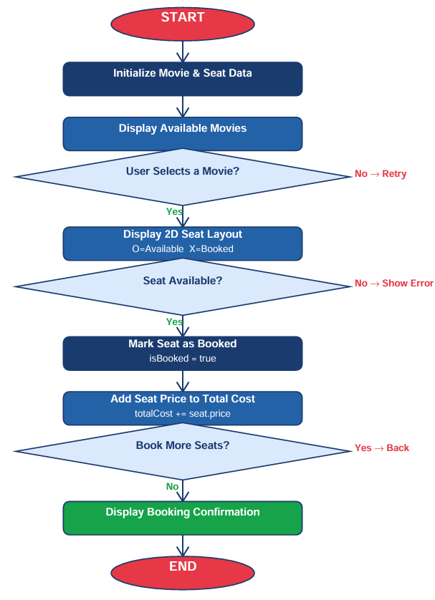

8. Class Diagram

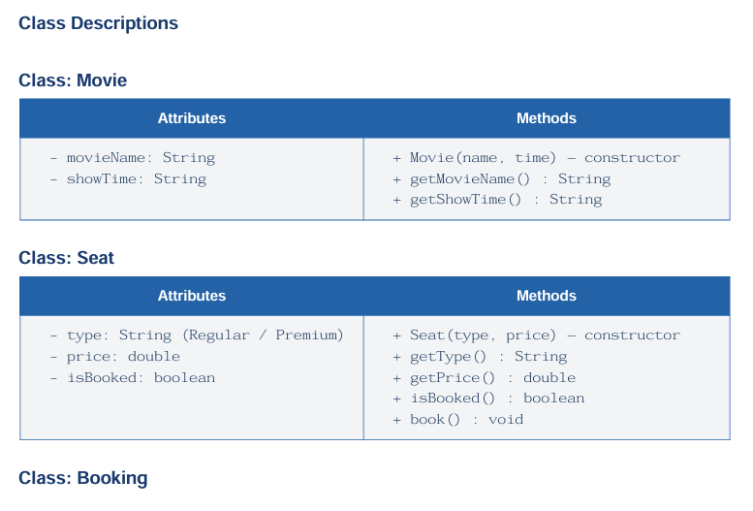
The UML class diagram below shows the three main classes and their relationships. The Booking class aggregates Seat objects via a 2D array and uses Movie to associate booking data with a film.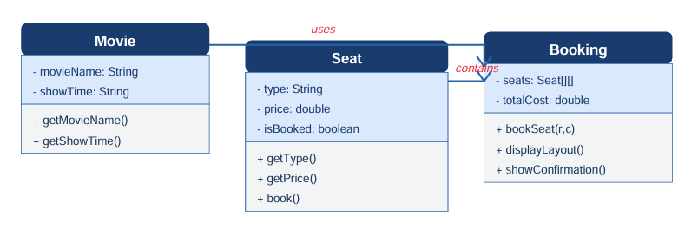

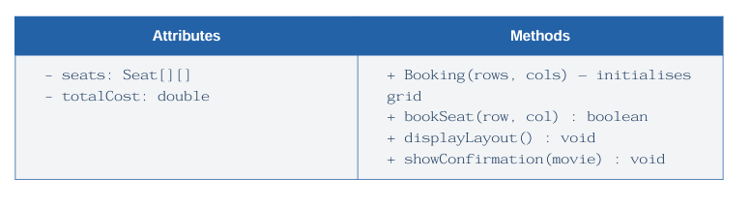

9. Implementation

9.1 Movie Class

The Movie class is the simplest component. Its constructor accepts a movie name and show-time string and stores them in private fields. Two getter methods expose these values. This class follows the encapsulation principle: data is private and only readable through controlled accessors.

9.2 Seat Class

Each Seat object tracks its category (Regular or Premium), its price, and its current booking status via a boolean flag isBooked. The book() method sets the flag to true. The booking engine calls this method after validating availability, separating validation logic from state mutation.

9.3 Booking Class

The Booking class is the core controller. Its constructor creates and populates a Seat[][] grid — rows 0–1 are Premium seats and rows 2–3 are Regular seats. The bookSeat(row, col) method first checks whether the target seat is already booked; if so it prints an error and returns false. Otherwise it invokes seat.book(), adds the seat's price to totalCost, and returns true. displayLayout() iterates the grid and prints 'O' or 'X' per seat. showConfirmation() prints the movie name, all booked seat co-ordinates, and the grand total.

9.4 Main Class

The Main class acts as the entry point and user-interface layer. It instantiates the Movie and Booking objects, displays the menu via System.out.println(), reads user input using a Scanner, and orchestrates calls to the Booking API. A simple loop lets users continue selecting seats until they choose to proceed to checkout

10. Sample Input / Output

10.1 Seat Layout Display

Available Movies:
1. Avengers: Endgame [Show: 7:00 PM]

Select movie (1): 1

--- Seat Layout --
C1 C2 C3 C4
Row 0: O O O O [Premium - Rs 300]
Row 1: O O O O [Premium - Rs 300]
Row 2: O O O O [Regular - Rs 150]
Row 3: O O O O [Regular - Rs 150]

10.2 Booking Interaction

Enter row (0-3): 0
Enter col (0-3): 2
Seat (0,2) booked successfully! [Premium - Rs 300]

Enter row (0-3): 2
Enter col (0-3): 1
Seat (2,1) booked successfully! [Regular - Rs 150]

Enter row (0-3): 0
Enter col (0-3): 2
ERROR: Seat (0,2) is already booked!

10.3 Booking Confirmation

========== BOOKING CONFIRMATION ==========
Movie : Avengers: Endgame
Show Time: 7:00 PM
Seats : (0,2) Premium | (2,1) Regular
-----------------------------------------
Total Cost: Rs 450 Thank you for booking with us!
========================================

11. Gantt Chart

The Gantt chart below outlines the project timeline across a four-week development cycle, from initial planning to final submission.

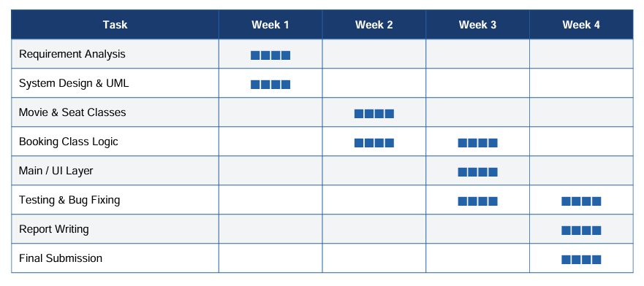

12. Future Enhancements

# Enhancement Details

1 Multiple Movies & Shows Support several movies with distinct show timings and
independent seat grids.

2 Row-Based Dynamic Pricing Apply different prices per row to simulate VIP, Gold, and
Silver tiers.

3 Seat Cancellation Allow users to cancel a booked seat and recalculate the total
cost.

4 Database Integration Persist booking data in MySQL/SQLite for history and
analytics.

5 JavaFX / Web GUI Replace the console interface with a graphical seat picker.

6 User Accounts Add login/signup to track bookings per customer.

7 Discount & Coupon System Apply promotional codes at checkout to reduce the total fare

13. Conclusion

The Movie Ticket Booking System successfully demonstrates the power of Object-Oriented Programming in solving a real-world problem. By modelling the domain as three co-operating classes — Movie, Seat, and Booking — the project achieves a clean separation of concerns, making the code easy to understand, test, and extend.

The use of a 2D array for seat management, combined with rigorous booking validation, ensures data integrity throughout the session. The system fulfils all functional requirements: displaying movies, rendering a live seat map, accepting user selections, preventing double-booking, calculating total cost, and printing a formatted confirmation.

This project serves as a strong foundation for further development toward a full-featured, database-backed reservation platform, and reinforces the importance of clean design principles in software engineering

14. References

